Only 25% citizens are clear about lockdown 3.0 rules
- Lack of clarity amongst citizens on what is permitted due to 3 set of guidelines, one each from MHA, State Government and District Administration
- Citizens appreciate MHA lockdown relaxations announced in green, orange and regular red zones
- 74% citizens want the State Governments and Local Administrations to undertake an extremely cautious approach in ‘high virus load districts’ and continue full lockdown there
7th May 2020, New Delhi: The Ministry of Home Affairs has extended the COVID-19 lockdown till May 17. The Government has announced a host of relaxations in Green, Orange to restart economic activity. The Government also approved some economic activity in red zones as well. The MHA circular dated May 1st also permits all private offices in red zones to operate with 33% staff, permits industrial activity in EOU, SEZs, etc. related to a set of sectors to also restart. Permission has also been granted for neighbourhoods and standalone shops to open and cars and two wheelers to operate, though all with the condition of social distancing and limited capacity norms being followed.
After the detailed MHA order, all State Governments and many District Magistrates or Collectors have also issued orders pertaining to their district. This has led to many citizens wondering about what is permitted, what is not and how should they go about their business as well as procuring certain products and services as a household that they postponed due to the 40 day lockdown. Given the citizen queries, LocalCircles decided to conduct a survey and better understand what people were going through. LocalCircles asked citizens if they were currently confused about what is permitted in their area in regards to functioning of local shops, eCommerce and business establishments. In response, 25% said they were totally confused while 34% said they were somewhat confused. Only 25% said they were completely clear about everything and 15% said they were not confused but had a small doubt.
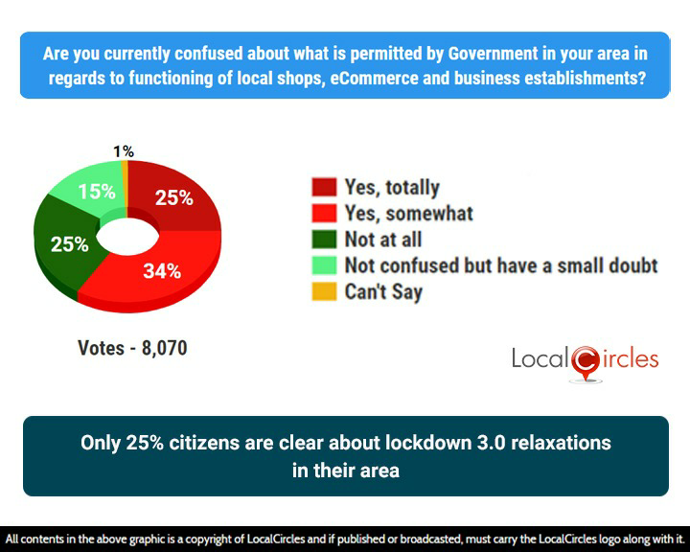
Many citizens have also raised the issue about state and local notifications being issued in languages without an English copy making them hard to understand for many. People want notifications to be in English as well as the common state language.

Many citizens have also raised concerns about the approach undertaken to unlock high virus load districts. People are in support of relaxations in the green and orange zones as well as in red zones that have a handful of cases but are greatly concerned about how high virus load districts are being treated at par with other red zone districts in terms of relaxations. High virus load districts as identified by the Niti Aayog two weeks ago included 27 districts of India where the intensity and number of cases of COVID-19 are exceptionally high. They include Mumbai, Delhi, Ahmedabad, Indore, Hyderabad and many other leading metros of the country.
Given the high number of concerns received about relaxations in these high load districts, LocalCircles also conducted a poll to get the collective opinion of people on whether additional restrictions are needed in these high virus load districts. A special focus in the survey was put on getting inputs from people residing in these 27 high load districts. Citizens were asked that given the MHA guidelines on relaxations in red zones, how should the State Governments and Local Administration go about relaxations in the high virus load districts. In response, 74% citizens expressed that NO lockdown relaxations should be given in these high virus load districts; 25% citizens said that red zone relaxations must apply to these high virus load districts. 1% did not have an opinion.
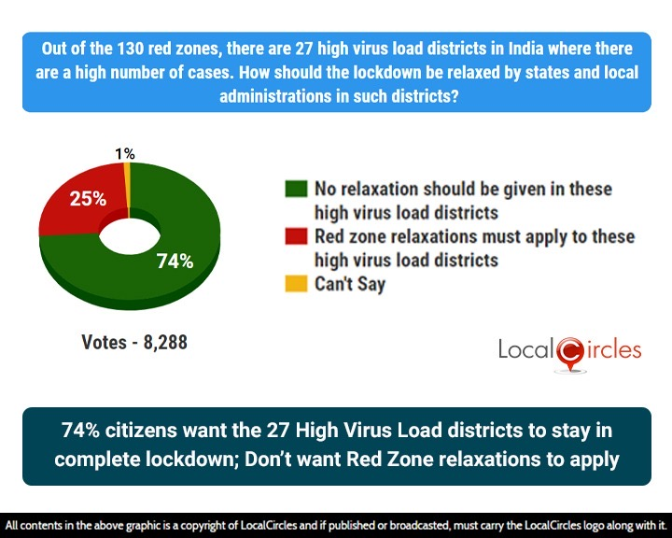
To put the citizens concern in perspective, on May 4th, Mumbai alone reported 510 new cases of COVID-19. The concern that citizens have is with such a high number of cases, any relaxation in lockdown will lead to much faster propagation of the virus resulting in a large number of cases in such high load districts in the coming weeks. As many liquor vends opened after almost 40 days, all the social distancing norms were flouted as large crowds gathered and people in big numbers queue outside a liquor shop. This might lead to an increase in COVID-19 infections by many folds. At the national level, on May 4th India reported 3656 new cases, highest single day number since the COVID-19 outbreak in India.
MHA has currently identified 130 districts as red zones of which these 27 high virus load districts are a part. Many citizens have specifically stated that given the urgent need to restart economic activity, a close watch must be kept on all these districts and as soon as they fall into regular red zone, category, the relaxations should start applying.
LocalCircles will be escalating these findings to all key stakeholders in the Central Government and various State Governments so they can be considered and if found fit, be incorporated in the lockdown management model of these 27 high load districts.

Survey Demographics
16,358 responses were received from 12,410 unique citizens located in over 277 districts of India. 66% respondents were men while 34% respondents were women. 42% respondents were from tier 1, 36% from tier 2 and 22% respondents were from tier 3, 4 and rural districts. They survey was conducted via LocalCircles platform and all participants are validated citizens who had to be registered with LocalCircles to participate in this survey.
About LocalCircles
LocalCircles, India’s leading Community Social Media platform enables citizens and small businesses to escalate issues for policy and enforcement interventions and enables Government to make policies that are citizen and small business centric. LocalCircles is also India’s # 1 pollster on issues of governance, public and consumer interest. More about LocalCircles can be found on http://www.localcircles.com
Media Contact: Akshay Gupta - media@localcircles.com, +91-8585909866

